Chili Cook Off is Back!

Friday July 28th

Opposite side as art hall

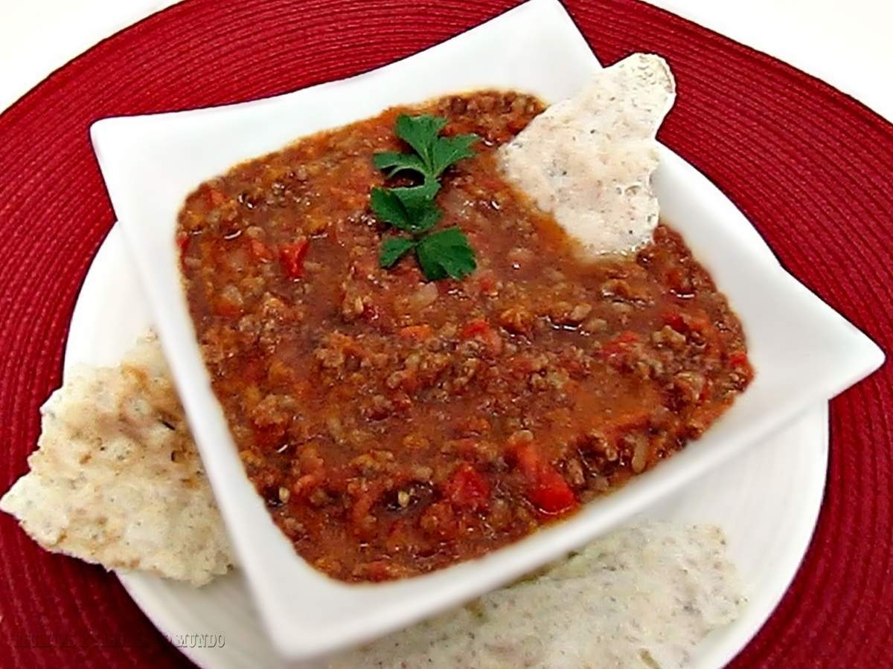

$5 dollar to enter a chili.

Must have enough chili for tasting of at least 30 people. Chili and be spicy or not. Must bring your own serving utensil. Tasting cups and spoons will be provided.

If you would like to come and taste but not make it will be,

$5 to enter and taste and vote on chili.

Thos tasting will be given 3 tickets when paying to use as your silent vote.